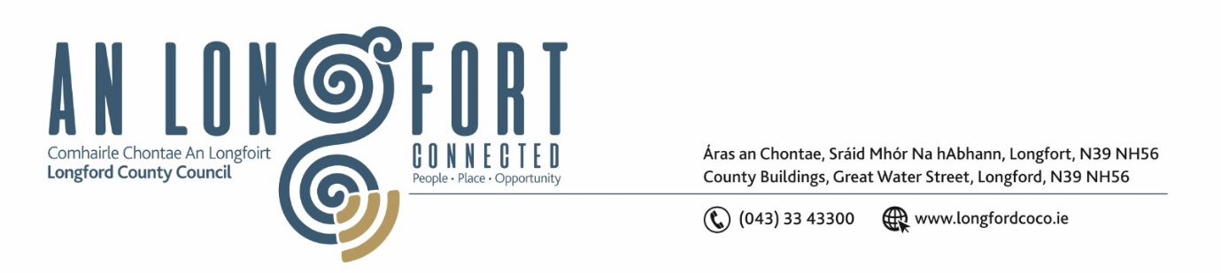

**LONGFORD MUNICIPAL DISTRICT**

**Minutes of Meeting of Longford Municipal District held in the Council Chamber Aras an Chontae and via MS Teams on Tuesday, 24 September 2024.**

**LEAS CATHAOIRLEACH**: Uruemu Adejinmi

**MEMBERS PRESENT**: Councillors Martin Monaghan, Cathaoirleach Councillor Seamus Butler

**IN ATTENDANCE**: Mr. John Brannigan, Director of Services

Ms. Louise Kiernan,

Ms. Lorraine McKee A/Senior Executive Officer

Mr. David McNiff

Michael Keenan and Longford Tidy Towns Committee

Mr. Richard Smith, Senior Executive Architect

**MEETINGS**

**ADMINISTRATOR:**  Mr. Gerard Dennigan

**APOLOGIES:** Peggy Nolan, Gerry Hagan, Kevin Hussey, Niall Gannon

**Longford Tidy Towns -Michael Keenan**

Michael Keenan delivered a comprehensive presentation to the members regarding Longford Tidy Towns. He outlined the concerns and proposed improvements aimed at enhancing the community's environment and overall appearance. The presentation included the following:

* Need for increased maintenance resources
* The use of the Multihog equipment
* IBAL Blackspots
* Concerns around the maintenance of car parks in Longford town
* Recent improvement works
* The importance of securing funding from the Community Recognition Fund to support initiatives.

Michael emphasised the importance of Longford County Council's support as a critical factor for future progress.

At the conclusion of the presentation, the members acknowledged the valuable insights provided. They recognised the significant work accomplished by Longford Tidy Towns and expressed their support moving forward.

Mr. John Brannigan, Director of Services, addressed the questions raised during the discussion. John stated that Longford County Council will continue to provide the best possible support to Longford Tidy Towns moving forward and acknowledged the exceptional work they have accomplished.

**Adjournment of meeting:**

Leas Cathaoirleach Uruemu Adejinmi informed the meeting that, in accordance with the standing orders requiring a quorum of four members, the meeting was adjourned due to the presence of only three members.

1. **DATE AND TIME OF NEXT MEETING**

The date of the next Longford MD meeting will take place on 15 October 2024.

This concluded the business of the meeting.

**Signed: ____________________**

**Gerard Dennigan,**

**A/ Meetings Administrator.**

**Confirmed and adopted at Longford Municipal District Meeting held on the 15 October 2024.**

**Signed: _______________**

**Leas Cathaoirleach**